Project Title:Retail Store Stock Inventory Analytics Project Design Phase-I - Solution Fit Template Team ID: PNT2022TMID52083

weee

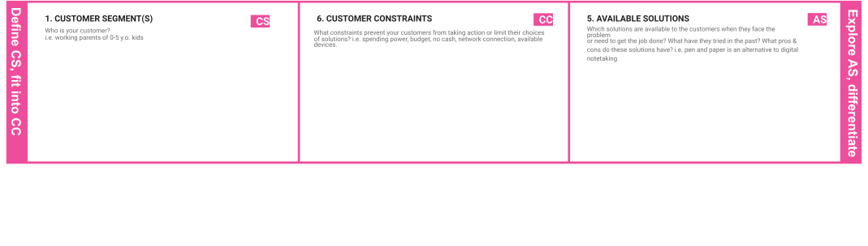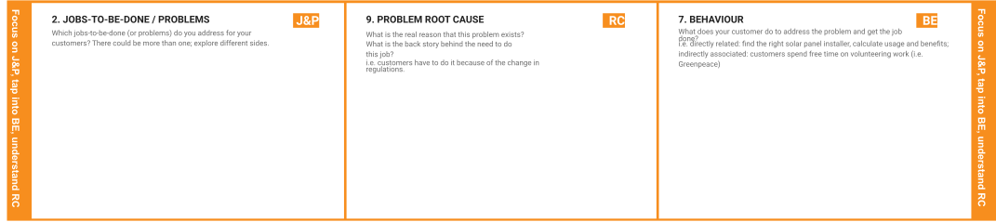

|  |  |  |  |  |
| --- | --- | --- | --- | --- |
|  | **3. TRIGGERS TR**  What triggers customers to act? i.e. seeing their neighbour installing solar panels, reading about a more efﬁcient solution in the news.  **Buy online pick up in store**  **Host events**  **Increase curb appeal**  **Create a lounge** | **10. YOUR SOLUTION SL**  If you are working on an existing business, write down your current solution ﬁrst, ﬁll in the canvas, and check how much it ﬁts reality.  If you are working on a new business proposition, then keep it blank until you ﬁll in the canvas and come up with a solution that ﬁts within customer limitations, solves a problem and matches customer behaviour.  **Finding new customers**  **Keeping existing customers**  **Selling more to existing customer**  **Improving customer service**  **Reducing personal cost**  **Reducing customer complaints**  **Decreasing time to market** | 1. **CHANNELS of BEHAVIOUR CH**    1. **ONLINE**   What kind of actions do customers take online? Extract online channels from #7   * 1. **OFFLINE**   What kind of actions do customers take ofﬂine? Extract ofﬂine channels from #7 and use them for customer development.  **ONLINE:**  **Advance**  **Choose which channel use**  **How to handle a complaint**  **Learn from mistakes**  **OFFLINE:**  **Take them seriously**  **Stay calm**  **Identify and anticipate needs**  **Suggest solution** |  |
| **4. EMOTIONS: BEFORE / AFTER EM**  How do customers feel when they face a problem or a job and afterwards?  i.e. lost, insecure > conﬁdent, in control - use it in your communication strategy design  **Neglecting store operation**  **Declining quality customer service**  **Forgetting about the data**  **Failing to adapt**  **Underestimating commitment to the store**  **Trying to do it alone** |

|  |  |  |  |  |
| --- | --- | --- | --- | --- |
|  |  |  |  |  |